**OBJECTIVE QUESTIONS AND ANSWERS**

1. What is the total no. of attributes present in the data?

Ans: 16

1. Which columns have inconsistent or missing values, and what is the count of such values?

Ans: Although no missing values were found in the dataset, several inconsistencies in categorical data were identified and resolved as part of the data cleaning process:

a. "Unclassified" spelling was corrected to "Unclassified" – 356 rows replaced.  
 b. "Mayor" spelling was changed to "Major” – 4,836 rowsreplaced.  
 c. "Unassigned" spelling was corrected to "Unassigned" – 29,410 rowsreplaced.  
 d. "Mid" spelling was changed to "Medium" – 15,845 rows replaced.

1. What is the average daily ticket volume over time?

Ans:

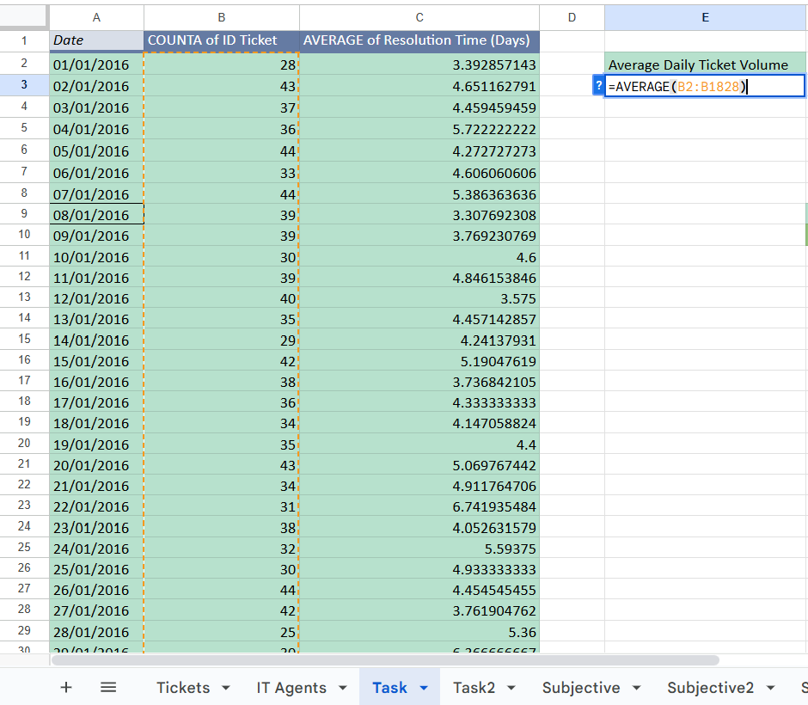

| **Average Daily Ticket Volume** |
| --- |
| 53.36507937 |

1. What is the distribution of ticket categories (e.g., Login Access, System, Software)?

Ans:

| *Request Category* | COUNTA of ID Ticket |
| --- | --- |
| Hardware | 9733 |
| Login Access | 29193 |
| Software | 19570 |
| System | 39002 |
| **Grand Total** | **97498** |

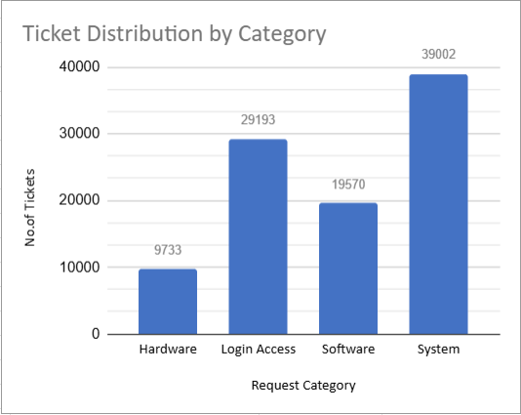

**5)** How many tickets has each agent handled?

Ans:

| *Agent ID* | COUNTA of ID Ticket |
| --- | --- |
| 1 | 1969 |
| 2 | 1968 |
| 3 | 2021 |
| 4 | 1988 |
| 5 | 2000 |
| 6 | 1949 |
| 7 | 1935 |
| 8 | 1960 |
| 9 | 1949 |
| 10 | 1974 |
| 11 | 1956 |
| 12 | 1897 |
| 13 | 1856 |
| 14 | 1942 |
| 15 | 1991 |
| 16 | 1926 |
| 17 | 1961 |
| 18 | 1892 |
| 19 | 1984 |
| 20 | 1920 |
| 21 | 1889 |
| 22 | 1966 |
| 23 | 1915 |
| 24 | 2003 |
| 25 | 1906 |
| 26 | 1963 |
| 27 | 1968 |
| 28 | 1946 |
| 29 | 1931 |
| 30 | 1963 |
| 31 | 1987 |
| 32 | 1974 |
| 33 | 1958 |
| 34 | 1927 |
| 35 | 2007 |
| 36 | 1913 |
| 37 | 1931 |
| 38 | 1938 |
| 39 | 2026 |
| 40 | 1920 |
| 41 | 1966 |
| 42 | 1945 |
| 43 | 1897 |
| 44 | 1943 |
| 45 | 1929 |
| 46 | 1950 |
| 47 | 1933 |
| 48 | 2027 |
| 49 | 1890 |
| 50 | 1949 |
| **Grand Total** | **97498** |

**6)** How can you extract the domain from the email addresses in the IT Agents sheet?

Ans:Byusing“=LEFT(RIGHT(C2,LEN(C2)-FIND("@",C2)),FIND(".",RIGHT(C2,LEN(C2)-FIND("@",C2)))-1)”.

**7)** How can you find the full name of an agent given their Agent ID?

Ans: “=PROPER(SUBSTITUTE(LEFT(C2, FIND("@", C2) - 1), ".", " "))” by using the above formula we can extract full name from email address and then using vlookup we can fetch full name to the Tickets sheet “=VLOOKUP(D2, 'IT Agents'!$A$1:$K$1048576, 9, 0)”.

**8)**  What is the count of each issue type (e.g., IT Error, IT Request)?

Ans:

| *Issue Type* | COUNTA of ID Ticket |
| --- | --- |
| IT Error | 24278 |
| IT Request | 73220 |
| **Grand Total** | **97498** |

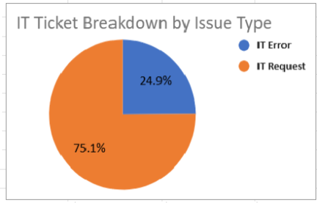

**9)** What is the daily average resolution time for tickets?

Ans:

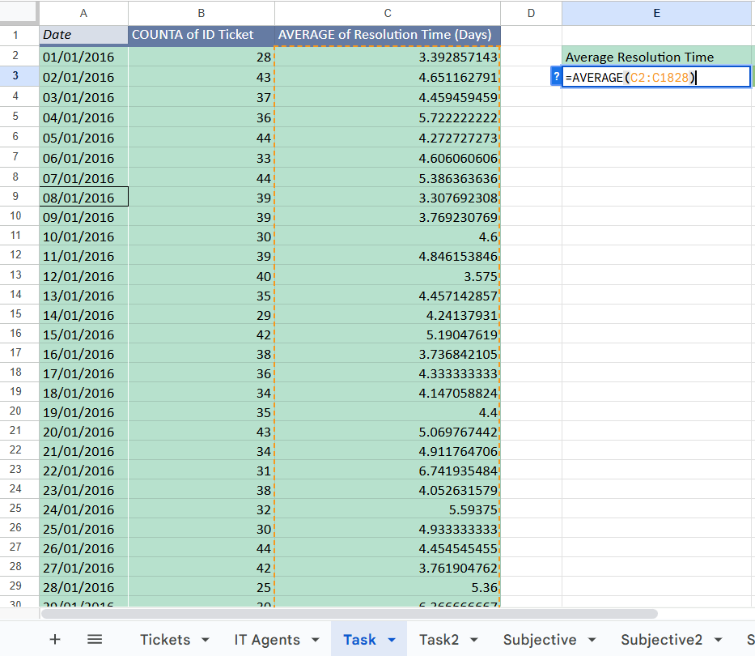

| **AVERAGE of Resolution Time** |
| --- |
| 4.548548054 |

**10)** How has the volume of tickets changed over time?

Ans: The volume of tickets has **consistently increased** every year from 2016 to 2020.

| *Year* | COUNTA of ID Ticket |
| --- | --- |
| 2016 | 13051 |
| 2017 | 14915 |
| 2018 | 18954 |
| 2019 | 21490 |
| 2020 | 29088 |
| **Grand Total** | **97498** |

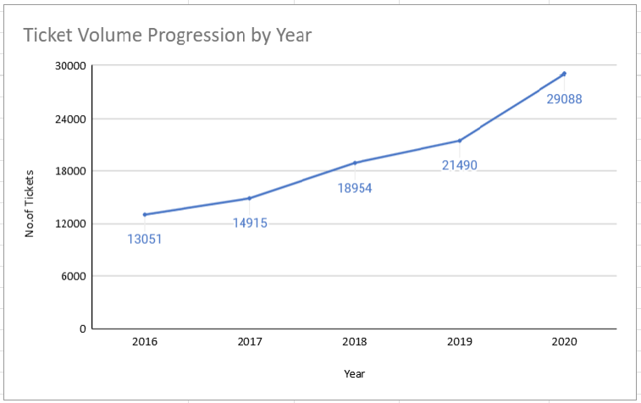

**11)** What is the average age of the IT agents?

Ans:

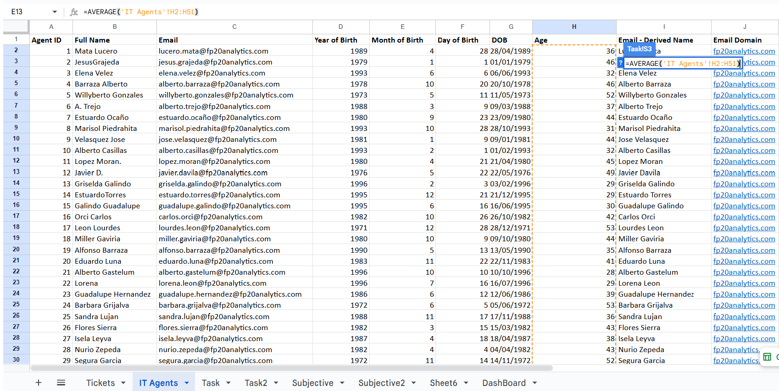

| **Average Age of IT Agents** |
| --- |
| 40.02 |

**12)** Is there a correlation between the severity of issues and the resolution time?

Ans: The correlation coefficient between issue severity and resolution time is **-0.0405**, indicating no strong relationship between the two variables. This suggests that severity levels do not significantly impact how long it takes to resolve a ticket.

| Correlation Between Severity Of Issues And Resolution Time |
| --- |
| -0.04053634915 |

**13)** How many categorical columns are there in the data? [Search about categorical and continuous data, and try to answer this question]

Ans: The dataset contains **6 categorical columns**, which are Request Category, Issue Type, Severity, Priority, Satisfaction Rate, and Agent Name.Categorical data refers to **non-numeric information** that classifies records into distinct groups.These values can be **nominal** (like names or types) or **ordinal** (with a logical order like severity levels).Such columns are important for grouping and are often converted into numbers for analysis or machine learning.

**SUBJECTIVE QUESTIONS AND ANSWERS:**

**1)** If there is an investment, should it be used to hire more IT agents, improve training programs, or upgrade ticket management software?

Analysis: Perform a cost-benefit analysis using ticket resolution and satisfaction metrics.

ANS:

| *Full Name* | AVERAGE of Resolution Time (Days) | AVERAGE of Satisfaction Rate |
| --- | --- | --- |
| Alberto Barraza | 5.24 | 4.19 |
| Alberto Casillas | 4.30 | 4.42 |
| Alberto Gastelum | 3.71 | 4.40 |
| Alberto Trejo | 5.32 | 3.59 |
| Aldo Carrillo | 4.55 | 3.78 |
| Alfonso Barraza | 5.00 | 3.04 |
| Alfredo Barreras | 4.29 | 3.67 |
| Armando Sierra | 5.34 | 4.36 |
| Aurelio Tanori | 4.51 | 4.41 |
| Barbara Grijalva | 4.23 | 4.44 |
| Carlos Orci | 4.32 | 3.67 |
| Darwin Echeverry | 4.06 | 4.36 |
| Diana Rojo | 3.64 | 4.60 |
| Eduardo Luna | 4.41 | 4.15 |
| Elena Velez | 5.38 | 3.62 |
| Enrique Montiel | 4.64 | 4.44 |
| Estuardo Ocaño | 5.52 | 3.98 |
| Estuardo Torres | 4.90 | 4.09 |
| Eva Cardenas | 4.72 | 4.41 |
| Flores Sierra | 4.75 | 3.99 |
| Griselda Galindo | 5.32 | 4.28 |
| Guadalupe Galindo | 3.66 | 4.47 |
| Guadalupe Hernandez | 4.56 | 4.38 |
| Guadalupe Torrico | 3.67 | 4.36 |
| Guadalupe Villanueva | 4.80 | 3.63 |
| Isela Leyva | 3.65 | 4.22 |
| Javier Davila | 4.06 | 4.49 |
| Jesus Contreras | 5.55 | 4.34 |
| Jesus Grajeda | 3.60 | 4.47 |
| Jesus Pacheco | 4.60 | 3.66 |
| Jose Velasquez | 4.52 | 3.69 |
| Lopez Moran | 4.78 | 3.64 |
| Lorena Leon | 5.51 | 3.63 |
| Lourdes Leon | 3.71 | 4.34 |
| Lucero Mata | 5.45 | 4.34 |
| Luis Arguello | 3.70 | 3.82 |
| Luis Torres | 3.92 | 4.20 |
| Marisol Piedrahita | 3.83 | 4.44 |
| Melinda Barcelo | 4.37 | 4.40 |
| Miller Gaviria | 4.73 | 3.99 |
| Nurio Zepeda | 5.41 | 3.61 |
| Parra Luna | 4.87 | 3.85 |
| Ramon Macias | 5.45 | 4.20 |
| Reyna Santacruz | 3.85 | 3.91 |
| Rosa Olguin | 5.32 | 4.32 |
| Sandra Lujan | 5.20 | 3.60 |
| Segura Garcia | 3.72 | 4.46 |
| Silvia Morales | 4.89 | 4.12 |
| Willyberto Gonzales | 4.26 | 4.38 |
| Yomaira Agudelo | 3.82 | 4.17 |
| **Grand Total** | **4.55** | **4.10** |

To decide whether the investment should go toward recruiting more IT agents, enhancing

training programs, or upgrading the ticketing system, we can evaluate the data by examining ticket resolution times and customer satisfaction scores. The following approach outlines key findings and suggestions based on the analysis.

**Analysis of Current Data**To decide whether to spend on hiring more IT agents, improving training, or upgrading the ticketing system, I looked at the data in three ways:

* First, I checked how the current agents are doing — how many tickets they handle, how fast they solve them, and how satisfied the users are.
* Then, I tried to see if training is making a difference — whether some agents are doing better than others because of training.
* Lastly, I looked at the ticketing system itself — to see if any delays or issues are happening because of how tickets are being assigned or handled.

**1. Hiring More IT Agents**

To check if more IT agents are needed, we looked at ticket data such as **Resolution Time (Days)**, **Severity**, and **Customer Satisfaction Rate**. The aim was to find out if the team is overloaded or if tickets are taking too long to close.

* **Resolution Time:** Most tickets are resolved within 4 days, which means the current team is handling the workload well. However, some tickets take 9–10 days, and a few even take up to 20 days.

| *Grouped Resolution Time (Days)* | COUNTA of ID Ticket |
| --- | --- |
| 0 - 4 | 51933 |
| 5 - 9 | 31762 |
| 10 - 14 | 10464 |
| 15 - 19 | 3335 |
| 20 - 24 | 4 |
| **Grand Total** | **97498** |

From the above chart Most tickets are resolved within 0–4 days, showing that agents handle most of the workload efficiently. A few tickets take 9–10 days, and only 4 tickets take up to 20 days, which may indicate overload or more complex cases.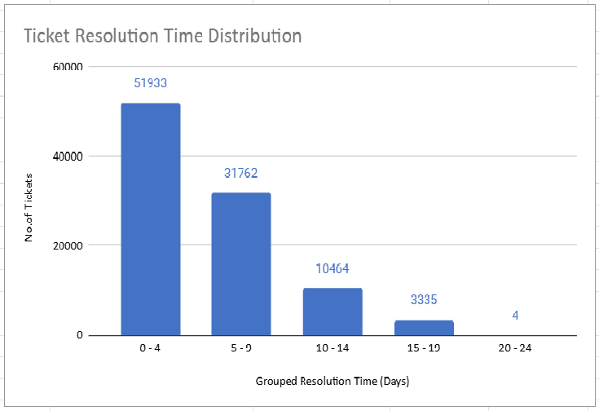

**Ticket Priority and Severity:** Many tickets are marked with a Severity Type of "Normal" or "Urgent." Urgent tickets usually require quicker handling but often take longer, which suggests that more experienced agents might be needed for these.

| *AVERAGE of Resolution Time (Days)* | *Priority* |  |  |  |  |
| --- | --- | --- | --- | --- | --- |
| *Severity Type* | 0 | 1 | 2 | 3 | Grand Total |
| Major | 4.13 | 4.60 | 3.70 | 3.62 | 3.91 |
| Minor | 4.30 | 5.25 | 3.69 | 1.01 | 3.44 |
| Normal | 5.42 | 6.13 | 4.06 | 3.60 | 4.66 |
| Unclassified | 4.11 | 4.08 | 3.00 | 0.57 | 2.88 |
| Urgent | 3.56 | 4.01 | 1.56 | 0.55 | 2.00 |
| **Grand Total** | **5.31** | **6.01** | **4.00** | **3.49** | **4.55** |

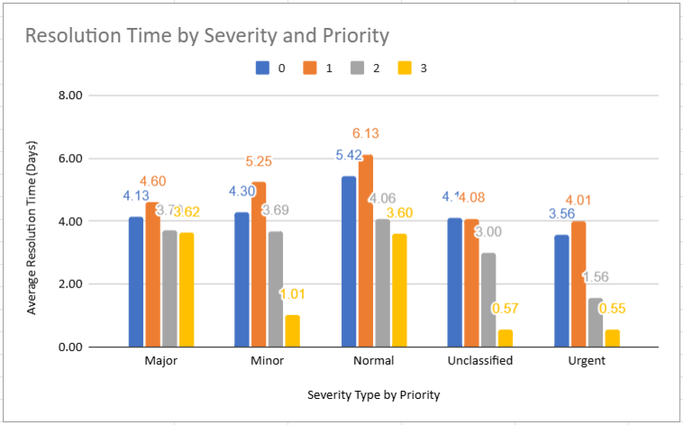

The Above chart compares the **average resolution time** of tickets for different severity types across priority levels (0–3). **Normal severity tickets take the longest to resolve**, especially at **priority levels 0 and 1**, where the average time exceeds **5 days**. **Minor severity tickets** also show delays at higher priority levels. **Urgent tickets are resolved the fastest**, averaging **2 days or less**, indicating that the support team prioritizes these critical issues. **Unclassified tickets** have the shortest resolution times overall, suggesting they are simpler cases.

**Satisfaction Rate:**

Overall customer satisfaction is high, with most tickets receiving top ratings. However, a noticeable number of tickets have a 1‑star rating, suggesting that some users were unhappy with response times or the quality of the resolution.

| *Satisfaction Rate* | COUNTA of ID Ticket |
| --- | --- |
| 1 | 9907 |
| 2 | 1977 |
| 3 | 7282 |
| 4 | 27562 |
| 5 | 50770 |
| **Grand Total** | **97498** |

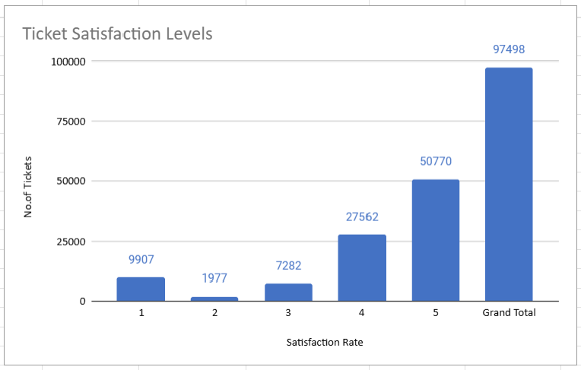

Above chart shows that Most tickets have a 5‑star satisfaction rating, showing that the overall performance of IT agents is strong. However, 9,907 tickets were rated 1 star, indicating that some customers were dissatisfied. To improve, the team needs to identify areas where agents are underperforming and take steps to enhance satisfaction. A focused review of agent performance, resolution times, and customer feedback will help address these issues and deliver better results.

**Recommendation for Hiring More IT Agents:** From the analysis, some tickets take up to **10 days** to resolve, showing that the current team may be overworked. Bringing in more IT agents can help spread the workload, especially for **urgent and high‑severity issues**. Priority should be given to hiring agents with **experience in critical problems** like login access and IT errors to reduce response times and improve overall service efficiency.

### **2. Improving Training Programs**

To see if better training could help, we looked at agent experience and performance. We also checked ticket resolution times and satisfaction rates to spot any gaps.

**Findings from the Ticket Data:**

* **Resolution Time:** Some agents close tickets very quickly, while others take up to 10 days. This big difference suggests that some agents may need extra training, especially in areas where they are slower.
* **Customer Satisfaction:** The average satisfaction rate is generally high, with many tickets getting 5 out of 5. However, some tickets were rated much lower (e.g., 1 out of 5), showing that a few customers were not happy with the support they got.

**Recommendation:** Provide focused training for agents who take longer to resolve tickets. This should include:

* **Technical training** on common issues like login errors and IT errors.
* **Customer service training** to improve how agents interact with users.
* **Mentorship programs**, where experienced agents with high satisfaction scores guide newer agents.

### **3. Upgrading Ticket Management Software**

We also reviewed the current ticketing system to see if it causes delays or inefficiencies.

**Findings from the Ticket Data:**

* **Unassigned Tickets:** Many tickets remain unassigned, causing delays in getting the right agent to handle them.
* **Severity and Priority Handling:** Some urgent tickets take longer to resolve, suggesting the system is not always routing tickets to the right agents based on urgency or skill.

**Recommendation:** Upgrade the ticket management system by:

* **Automating ticket assignment** so urgent or complex issues go directly to the right agents.
* **Using priority filters** to ensure high-priority tickets are handled first.
* **Tracking agent performance** within the system to spot patterns and take action if resolution times or satisfaction drop.

### **Overall Analysis and Recommendations**

* **Hiring More IT Agents:** Some tickets still take too long to resolve. Hiring more agents, especially those skilled in high-severity issues, will help reduce delays.
* **Improving Training Programs:** Differences in resolution times and satisfaction rates show that some agents need extra technical and customer service training.
* **Upgrading Ticket Management Software:** Better automation and smarter routing will ensure the right tickets reach the right agents faster.

Combining these three steps will make IT support more efficient, shorten resolution times, improve customer satisfaction, and help the team handle ticket volumes more effectively.

**2**. Which agents need additional training based on their performance metrics?

Analysis: Identify agents with the lowest satisfaction ratings and longest resolution times.

| *Agent ID* | AVERAGE of Resolution Time (Days) | AVERAGE of Satisfaction Rate |
| --- | --- | --- |
| 1 | 5.44591163 | 4.340274251 |
| 2 | 3.596544715 | 4.473577236 |
| 3 | 5.381989114 | 3.615042058 |
| 4 | 5.243963783 | 4.187625755 |
| 5 | 4.259 | 4.376 |
| 6 | 5.32067727 | 3.592611596 |
| 7 | 5.524031008 | 3.97622739 |
| 8 | 3.834183673 | 4.436734694 |
| 9 | 4.523345305 | 3.690097486 |
| 10 | 4.298378926 | 4.415906788 |
| 11 | 4.778118609 | 3.63803681 |
| 12 | 4.05640485 | 4.489720611 |
| 13 | 5.322198276 | 4.282327586 |
| 14 | 4.901132853 | 4.085478888 |
| 15 | 3.655951783 | 4.4716223 |
| 16 | 4.317757009 | 3.665109034 |
| 17 | 3.705252422 | 4.341662417 |
| 18 | 4.731501057 | 3.991014799 |
| 19 | 4.999495968 | 3.04233871 |
| 20 | 4.4078125 | 4.147916667 |
| 21 | 3.705664373 | 4.401270513 |
| 22 | 5.511190234 | 3.628179044 |
| 23 | 4.55770235 | 4.377545692 |
| 24 | 4.227159261 | 4.441337993 |
| 25 | 5.204616999 | 3.601259182 |
| 26 | 4.754457463 | 3.990830362 |
| 27 | 3.651422764 | 4.222052846 |
| 28 | 5.409558068 | 3.612024666 |
| 29 | 3.716727084 | 4.461418954 |
| 30 | 4.867040245 | 3.847682119 |
| 31 | 3.66935078 | 4.364368395 |
| 32 | 4.886524823 | 4.123100304 |
| 33 | 4.804392237 | 3.631256384 |
| 34 | 3.636222107 | 4.596782564 |
| 35 | 4.369207773 | 4.399103139 |
| 36 | 3.918452692 | 4.198118139 |
| 37 | 4.595028483 | 3.660797514 |
| 38 | 4.643446852 | 4.444272446 |
| 39 | 5.554787759 | 4.344521224 |
| 40 | 4.286979167 | 3.667708333 |
| 41 | 4.554933876 | 3.783316378 |
| 42 | 4.058097686 | 4.361953728 |
| 43 | 3.846072746 | 3.913020559 |
| 44 | 4.720020587 | 4.411219763 |
| 45 | 3.700362882 | 3.821150855 |
| 46 | 5.319487179 | 4.320512821 |
| 47 | 3.824624935 | 4.170201759 |
| 48 | 4.514553527 | 4.407992107 |
| 49 | 5.343915344 | 4.355026455 |
| 50 | 5.451513597 | 4.204720369 |
| **Grand Total** | **4.553149808** | **4.100648218** |

| Agent Id | Lowest Satisfaction Rating |
| --- | --- |
| 19 | 3.04233871 |

| Agent Id | Longest Resolution Time |
| --- | --- |
| 39 | 5.554787759 |

From the above metrics, it is clear that agents with IDs **19** and **39** would benefit from additional training to improve their performance.

**3**.Do certain categories of requests have longer resolution times?

Analysis: Analyze the resolution times by request category.

Ans:

| *Request Category* | AVERAGE of Resolution Time (Days) |
| --- | --- |
| Hardware | 7.62539813 |
| Login Access | 0.3138081047 |
| Software | 5.238732754 |
| System | 6.615609456 |
| **Grand Total** | **4.553149808** |

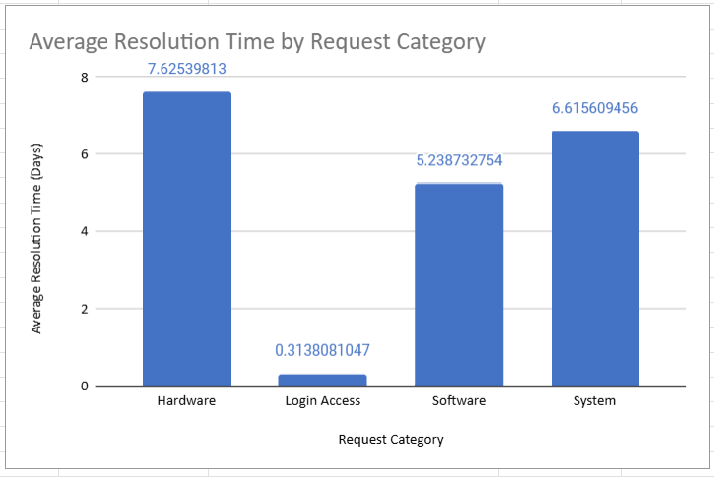

**Identified Issues:**

* **Complex Issues**: Hardware requests often require detailed checks, troubleshooting, or part replacements, leading to longer handling times.
* **Resource Shortages**: Limited staff, tools, or spare parts can delay resolutions.
* **High Demand**: A larger volume of hardware-related tickets strains existing support processes.
* **Skill Gaps**: Not all agents have advanced hardware troubleshooting expertise.
* **System Dependencies**: Hardware fixes may rely on other systems, creating bottlenecks.

**Improvement Strategies:**

* **Process Improvements**: Streamline hardware request workflows and implement clear Standard Operating Procedures (SOPs) to speed up ticket handling.
* **Skill Development:** Provide targeted training programs to enhance staff expertise in troubleshooting and resolving hardware issues.
* **Resource Allocation:** Assign additional support teams and maintain an adequate inventory of hardware components to manage high demand.
* **User Empowerment:** Offer self-service tools and knowledge bases, enabling users to resolve common hardware problems on their own.
* **Performance Monitoring**: Continuously track resolution times and analyze common issues to address recurring problems proactively.
* **Feedback Mechanism:** Collect regular user feedback to understand pain points and improve the overall resolution process.

Addressing these areas can lead to shorter resolution times for hardware requests and a significant improvement in overall service efficiency.

**4)** How effective are the current software tools in managing IT tickets?

Analysis: Evaluate performance metrics before and after the implementation of new tools.

**Ans:** To determine how effective the current software tools are in managing IT tickets, we need to compare **key performance metrics** before and after their implementation.

**Performance Metrics:**

* **Resolution Time (Days):** Measures how quickly IT tickets are resolved from creation to closure. Shorter times mean faster issue handling and improved support efficiency.
* **Satisfaction Score:** Represents end-user feedback on the quality of service received. Higher scores indicate better user experience and greater confidence in IT support.

| *Month* | AVERAGE of Resolution Time (Days) | AVERAGE of Satisfaction Rate |
| --- | --- | --- |
| Jan | 4.58 | 4.15 |
| Feb | 4.59 | 4.07 |
| Mar | 4.56 | 4.07 |
| Apr | 4.56 | 4.11 |
| May | 4.56 | 4.11 |
| Jun | 4.62 | 4.09 |
| Jul | 4.55 | 4.12 |
| Aug | 4.50 | 4.10 |
| Sep | 4.50 | 4.10 |
| Oct | 4.56 | 4.08 |
| Nov | 4.51 | 4.09 |
| Dec | 4.55 | 4.10 |
| **Grand Total** | **4.55** | **4.10** |

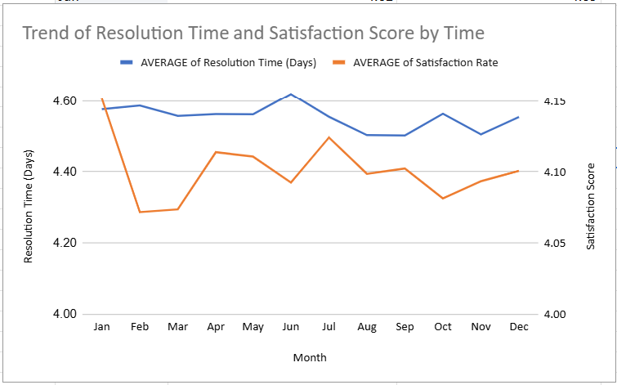

### 

### **What the Chart Shows**

* **Ticket Resolution Trends:** The blue line shows how long it takes to close tickets. Times go up and down a lot, meaning the software isn’t giving steady results. Some months, like July, take much longer, and others are quicker. Ideally, after new tools are added, we should see times slowly go down.
* **User Feedback Levels:** The orange line shows that customer satisfaction stayed almost the same all year. Even though resolution times change, users are not very unhappy. However, there’s no big improvement, and the slight drop later in the year could mean people are slowly getting frustrated.

### **How the Tools Are Performing**

* After installing the new software, satisfaction stayed stable, but resolution times didn’t become faster or more consistent. The blue line doesn’t show a clear improvement, meaning the tools may not fully fix delays or manage busy months well.

### **Next Steps for Better Results**

* **Use Smart Prioritization & Automation:** Let the system handle simple tickets automatically, so agents can focus on harder issues. Make sure urgent tickets are handled first. Use reports to find months when resolution time gets worse and act before problems grow.
* **Dig Deeper into Other Factors:** Since satisfaction didn’t change much even when times did, check other things like ticket priority and severity. This can show where improvements are needed and where the software could work better.

| *Severity* | COUNTA of ID Ticket |
| --- | --- |
| 0 - Unclasified | 356 |
| 1 - Minor | 2258 |
| 2 - Normal | 88656 |
| 3 - Mayor | 4836 |
| 4 - Urgent | 1392 |
| **Grand Total** | **97498** |

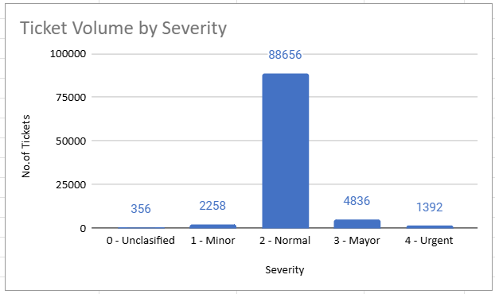

From the above chart, we can see that most of the tickets are in the Normal severity category, showing that routine issues make up the majority. Still, there are also a good number of Major and Urgent tickets that need quick attention. We should focus more on handling these high-priority issues by planning resources better. Using predictive tools can help us prepare for sudden ticket spikes and assign the right staff at the right time, which will keep resolution times low and improve overall service.

| *Priority* | COUNTA of ID Ticket |
| --- | --- |
| 0 - Unassiged | 29410 |
| 1 - Low | 16694 |
| 2 - Mid | 15845 |
| 3 - High | 35549 |
| **Grand Total** | **97498** |

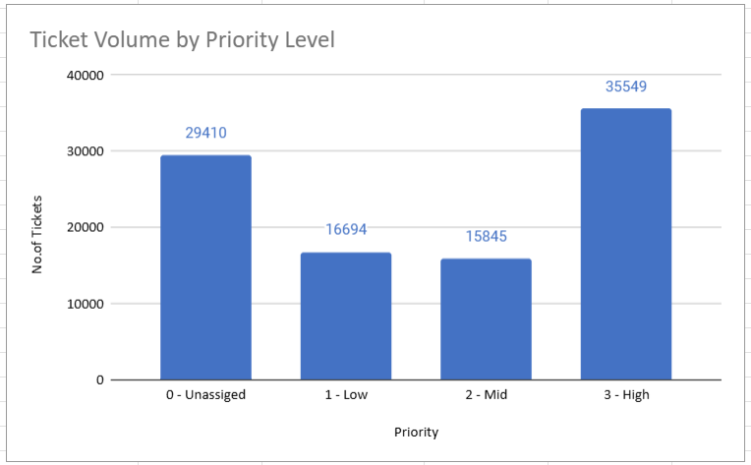

From the above chart, we can see that **High-priority tickets account for the largest share (35,549)**, followed closely by a significant number of **Unassigned tickets (29,410)**. This indicates that **a large portion of requests either need immediate attention or have yet to be prioritized**, which can affect response times. **Improving ticket assignment and focusing on high-priority issues** will help streamline workflows. Using **forecasting tools** can also help predict priority spikes and ensure enough staff are available to handle urgent tasks efficiently.

**Overall Findings:** From the analysis, it is clear that while the current tools help in keeping customer satisfaction steady, they are not very effective in bringing down resolution times. To improve overall performance, we need to **focus on automation, better communication, and smarter resource allocation**, especially during busy periods. By doing this, we can handle tickets faster, reduce delays, and keep customer satisfaction at a good level.

**5**.How has the performance of the IT support team changed over time (e.g., monthly or quarterly)?

Analysis: Trend analysis using time series charts.

Ans: By checking our IT support ticket system, I found that **ticket volumes are increasing steadily over time**. This shows that our IT agents are getting more workload, and we need **better tools and processes** to manage it. If we look at **resolution times, automation, and user satisfaction**, we can find areas to improve and help our team handle tickets more effectively.



| *Month* | COUNTA of ID Ticket | AVERAGE of Resolution Time (Days) |
| --- | --- | --- |
| Jan | 7242 | 4.575807788 |
| Feb | 7901 | 4.586254904 |
| Mar | 8228 | 4.557243559 |
| Apr | 7937 | 4.562429129 |
| May | 8121 | 4.561384066 |
| Jun | 8141 | 4.619579904 |
| Jul | 8070 | 4.554522924 |
| Aug | 8489 | 4.502886088 |
| Sep | 8219 | 4.502129213 |
| Oct | 8495 | 4.562919364 |
| Nov | 8254 | 4.505330749 |
| Dec | 8401 | 4.553862635 |
| **Grand Total** | **97498** | **4.553149808** |

| *Date* | COUNTA of ID Ticket |
| --- | --- |
| Q1 | 23371 |
| Q2 | 24199 |
| Q3 | 24778 |
| Q4 | 25150 |
| **Grand Total** | **97498** |

By checking the **yearly, monthly, and quarterly ticket trends**, I found that **ticket volumes are consistently going up**, which means the demand on our IT support team is growing. According to **IT Service Management (ITSM) best practices**, rising ticket volumes can lead to longer resolution times and lower customer satisfaction if not managed properly.

**Suggestions for Improvement:**

* **Improve ticket software** by adding automation, reporting, and easy-to-use features. Integration with other IT tools can make workflows smoother.
* **Use automation** for repetitive issues like password resets and include AI chatbots for quick support, reducing agent workload.
* **Analyze resolution times** regularly to find bottlenecks and set performance benchmarks to keep track of progress.
* **Provide continuous training** for agents on tools, processes, and customer handling; encourage sharing of knowledge within the team.
* **Collect and act on feedback** from users after tickets are resolved to improve satisfaction.
* **Prioritize tickets smartly**, ensuring critical problems are solved first and SLAs are followed.
* **Expand support options** like chat, phone, email, and self-service portals so users can choose what suits them best.
* **Monitor KPIs** like ticket volume, resolution times, and satisfaction scores to understand where improvements are needed.

By following these points, we can **handle the rising workload better, improve agent efficiency, and keep users happy**.

**6.**  If we invest more on tech (Hardware, software, etc), do you think it will improve the ticket resolution times and employee satisfaction?

Analysis: Use historical data to project potential improvements

Ans:

Upgrading to better technology can make solving tickets faster and easier. It helps teams work more smoothly and reduces delays. Employees will also feel happier because their work becomes less stressful. To get these benefits, proper setup and training are very important.



By looking at the factsheet, we can see that tickets with higher satisfaction rates are the most common. Most of the tickets handled by the team have a good satisfaction score, showing that customers are mostly happy with the support they receive. This means the agents are doing their job well and meeting user needs. Maintaining this level of service can help keep customers satisfied and build trust in the support team.

| *Issue Type* | SUM of Resolution Time (Days) |
| --- | --- |
| IT Error | 75521 |
| IT Request | 368402 |
| **Grand Total** | **443923** |

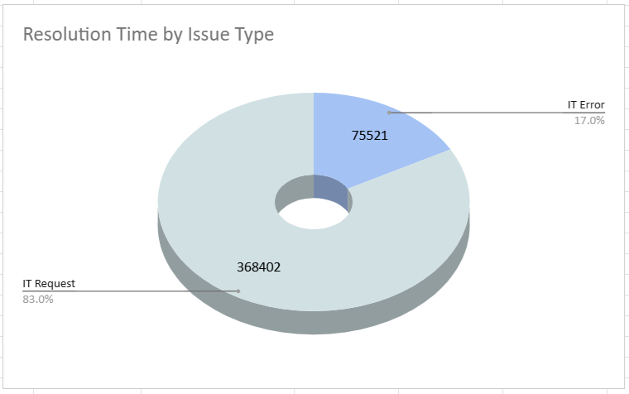

The resolution time for IT request categories is quite high, which can slow down overall support. Introducing new technologies can help make the process faster and smoother. With better tools, agents can solve issues more quickly and handle more requests without delays. This improvement will support future growth and keep both customers and employees satisfied.

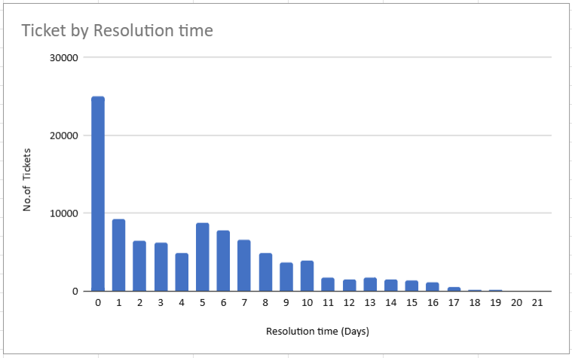

By looking at the chart, we can see that most tickets are resolved in less than 7 days. However, using tools like Chatbots, AI, and ML can make the process even faster and reduce the chances of human errors. These technologies can handle simple tasks automatically, leaving agents free to focus on more complex issues. This will improve efficiency and make the overall support system more reliable.

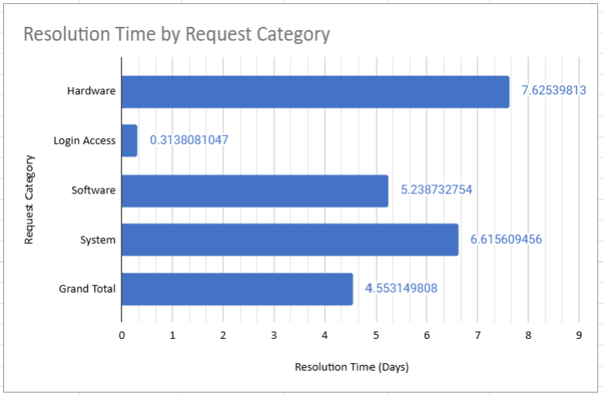

By looking at the above chart, we can see that hardware and system requests are taking more time to resolve compared to other categories. This delay adds pressure on the support team and slows down overall service. Introducing hardware engineering and using new technologies can help reduce this burden by making the process faster and more efficient. With these improvements, the workload on agents will decrease, and customers will receive quicker solutions.

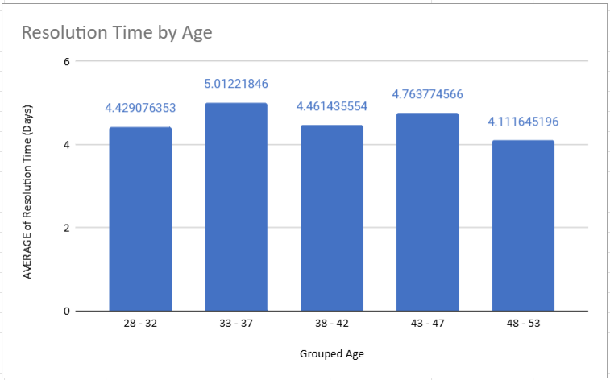

By looking at the chart, we can see that the average resolution time is nearly the same across all age groups, staying around 4 to 5 days. However, the age group 33–37 takes the most time, with an average of about 5 days. This delay could be due to certain socio-economic factors affecting this group. Addressing these issues can help bring their resolution time closer to the overall average.

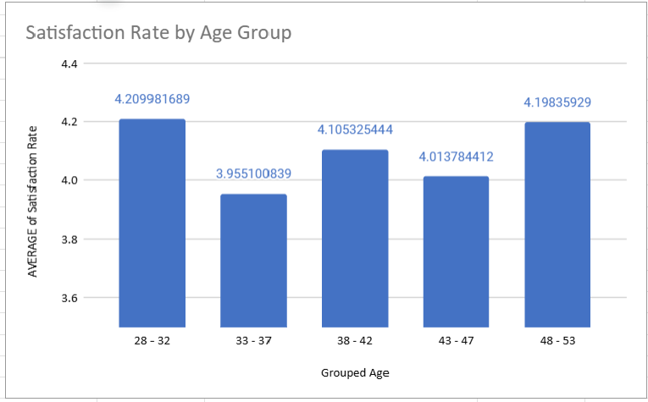

By looking at the data, we can see that the satisfaction rate for the **28–32** age group is higher than the middle-aged groups. This gap can be reduced by giving proper training and using AI and ML tools.

**Conclusion:**

* Most of the tickets are solved in less than 7 days, leading to higher satisfaction, especially in IT requests.
* Using Chatbots, AI, and ML can reduce human errors and make the process faster, giving a better user experience.
* Hardware and system tickets are taking more time; by using advanced tools and hardware engineering, this can be improved.
* Most age groups take almost the same time, but the **33–37** group takes a bit longer; checking socio-economic reasons can help reduce this.
* The **28–32** group has the best satisfaction rate; middle-aged groups can improve by training and using AI tools.

**Recommendations:** Use modern tools like CRM and automated ticketing to make work faster and easier.  
 Provide self-service options like FAQs and chatbots to reduce the workload.  
 Make special teams for complex tickets and keep a knowledge base for quick answers.  
 Give proper training and updates to staff to keep them ready for new challenges.  
 Faster resolution means happier users and helps the team manage more tickets.  
 Understand the needs of all age groups to make support better for everyone.

In short, using new technology, better training, and support will reduce resolution times, improve satisfaction, and help future growth.

**7)** What are the key performance metrics for IT agents, and how can they be improved, do we need to fire any agents?

Analysis: Define and analyze metrics such as average handling time, satisfaction scores, and number of tickets resolved.

Ans:

**Key Performance Metrics for IT Agents**

* **Ticket Resolution Time:** Shows how long it takes to close a ticket.  
   *Improvement:* Give better training and use new tools to solve tickets faster.
* **First Contact Resolution (FCR) Rate:** Tells how many issues are fixed in the first call or chat.  
   *Improvement:* Improve knowledge base and help agents fix issues without passing them on.
* **Customer Satisfaction (CSAT) Score:** Shows how happy customers are with the service.  
   *Improvement:* Give customer service training and follow up on time to keep customers satisfied.







**Things to Check Before Terminating an IT Agent**

* **Give a Chance to Improve** Before thinking of firing someone, first try to help them get better. Set clear goals, provide extra training, and give the right tools so they can improve their work.
* **Understand Why Performance is Low** Don’t just look at the numbers; find out the real reason. Maybe they didn’t get proper training, maybe there are not enough resources, or they might be facing personal problems.
* **Think About the Team Impact** Firing an agent can lower team morale and increase work pressure on others. Check how this decision will affect the team’s overall performance.
* **Be Fair and Follow Rules** Any termination should follow company policies and legal rules. Being fair and transparent keeps trust within the team.
* **Focus on Support and Growth** Improving performance should always come first. Work on training programs, better processes, and smarter use of technology. Review all performance data properly before making a final decision, and only consider termination if all other steps have failed.

To make IT agents work better, give them proper training, improve the processes, and use technology in the best way. Check their performance data carefully before thinking about termination, and always try to help and support underperforming agents to improve first.

**8)** How do employee demographics (e.g., department, seniority) impact satisfaction and ticket outcomes?

Analysis: Segment analysis using filters and pivot tables.

Ans:

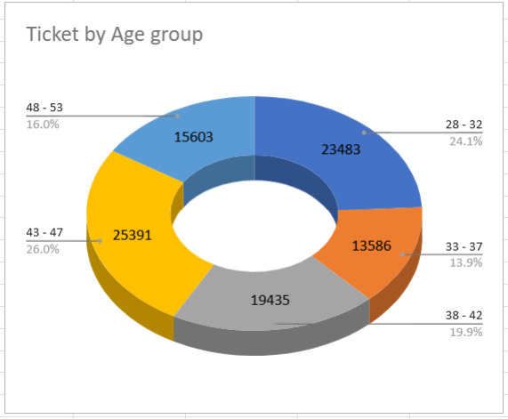

From the pie chart, we can see that higher age groups have more tickets compared to lower age groups. This means older users are creating more tickets than younger ones. By checking this trend, we can plan offers, products, or strategies for younger people to keep the balance between all age groups.

The data shows that the satisfaction rate is higher for the **28–32** age group compared to middle-aged groups. This gap can be improved by giving proper training and using AI and ML tools. Training will help build skills and solve the needs of middle-aged groups, and AI/ML tools can give better support and make work faster. These steps can help increase satisfaction for all age groups.

**What the Data Shows:** Older people are buying more tickets, showing that their interest and engagement are going up compared to younger groups. Younger people seem less active or may have problems that stop them from buying tickets.

**Who is More Satisfied:** The **28–32** age group has a higher satisfaction rate. Their experience seems better than middle-aged groups, so we need to find what makes them happier.

**How to Get Young People Interested** Make campaigns just for younger users using social media and influencers they like. Give offers like group discounts or bundles that match their interests.

* **New Ideas for Products** Plan events and products that younger people enjoy, like music shows, gaming events, or tech expos. Ask for their feedback to know what they want and what problems they face.
* **Better Pricing Plans** Use flexible prices like early-bird discounts or tiered models to make tickets affordable. Create loyalty programs to keep younger buyers engaged.
* **Training for Staff** Give training to middle-aged staff so they can meet the latest market needs. Arrange workshops to understand their problems and help them improve.
* **Using AI and ML** Use AI to learn what customers like and ML to give personal suggestions, making the service better and faster.
* **Keep Listening to Feedback** Take regular feedback from all age groups with surveys or focus groups. This helps improve services and meet everyone’s needs.

**Overall Plan:** By working on marketing, pricing, new products, training, and technology, we can balance satisfaction and engagement across all ages, helping the business grow.

**9)** Identify the trends for IT support operations based on ticket volumes and satisfaction, and mention the peak and stable times?

Analysis: Use pivot tables and charts to identify peak and off-peak hours

Ans:

| *Year* | COUNTA of ID Ticket |
| --- | --- |
| 2016 | 13051 |
| 2017 | 14915 |
| 2018 | 18954 |
| 2019 | 21490 |
| 2020 | 29088 |
| **Grand Total** | **97498** |



| *Satisfaction Rate* | COUNTA of ID Ticket |
| --- | --- |
| 1 | 9907 |
| 2 | 1977 |
| 3 | 7282 |
| 4 | 27562 |
| 5 | 50770 |
| **Grand Total** | **97498** |

**Insights**

* **Tickets Going Up:** Tickets are increasing, which means more customer activity or some problems that need to be fixed.
* **Most Users Happy:** More than half of the tickets get a satisfaction score of 5, showing good handling.
* **Some Still Unhappy:** The rest have lower scores, meaning some issues still need more focus.
* **Team Under Pressure:** More tickets with low scores may mean the team is overloaded, causing delays or missed details.
* **Different Needs:** The gap in ratings shows some customers have different expectations that are not fully met.

**Recommendations**

* **Check Trends:** Look at ticket types and scores to find out why some users are unhappy.
* **Tiered Support:** Send tough tickets to skilled agents for better results.
* **Hire More Agents:** Add staff in busy times to manage the load and keep quality.
* **Train the Team:** Give training for handling low-rated tickets, focusing on problem-solving and empathy.
* **Better Knowledge Base:** Make FAQs and guides so agents and users can find answers faster.
* **Use Feedback:** Collect feedback after each ticket to improve the process.
* **Watch KPIs:** Keep checking ticket volume, resolution time, and satisfaction to catch problems early.
* **Use Automation:** Automate simple tasks to reduce workload and speed up replies.

**In Short** Fixing these areas can make customers happier and help the team handle more tickets easily.

**10)** What metrics should be included in the final dashboard to provide a comprehensive view of call center performance and guide investment decisions?

**Ans:**  To build a complete dashboard that shows call center performance and supports investment decisions, these metrics and visuals should be included:

**Customer Satisfaction Score (CSAT) Over Time**

* *Chart:* Line chart
* *Use:* Shows how customer satisfaction changes over time, helping to check if service improvements are working and find any issues.

**Average Resolution Time by Request Category**

* *Chart:* Bar chart
* *Use:* Displays the average time to solve different types of requests like technical support or billing. Helps see which areas need more attention or resources.

**Employee Satisfaction Score Distribution**

* *Chart:* Pie chart or histogram
* *Use:* Shows how satisfied the employees are. Understanding team morale helps improve overall performance.

**Employee Resolution Time Distribution**

* *Chart:* Box plot
* *Use:* Shows how fast different employees resolve tickets, pointing out top performers and those who may need more support or training.

**Conclusion:**  
 Including these metrics gives a clear view of call center operations. Studying customer and employee satisfaction, resolution times, and ticket data helps managers make better choices about resources, training, and process changes, improving service quality and efficiency.